Note on 'Python walk-through for Titanic data analysis'.md
Source: https://www.kaggle.com/headsortails/pytanic

The routine of the analysis
- Load Data and Modules (complete)
- Initial Exploration (complete)
- Relations between features (complete)
- Missing values (complete)
- Derived (engineered) features (largely complete)
- Preparing for modelling (complete)
- Modelling (medium completeness; to be extended)
- Preparing our prediction for submission (complete)

Load Data and Modules (Always used)

Load Modules
#%matplotlib inline

# for seaborn issue:
import warnings
warnings.filterwarnings("ignore")

import pandas as pd
import numpy as np
from scipy import stats
import sklearn as sk
import itertools
import matplotlib.pyplot as plt
import matplotlib.gridspec as gridspec
import seaborn as sns
from statsmodels.graphics.mosaicplot import mosaic

from sklearn.linear_model import LogisticRegression
from sklearn.linear_model import Perceptron
from sklearn import tree
from sklearn.naive_bayes import GaussianNB
from sklearn.neighbors import KNeighborsClassifier
from sklearn.ensemble import RandomForestClassifier
from sklearn.ensemble import ExtraTreesClassifier
from sklearn.ensemble import BaggingClassifier
from sklearn.ensemble import AdaBoostClassifier
from sklearn.ensemble import GradientBoostingClassifier
from sklearn.ensemble import VotingClassifier
from sklearn import svm
import xgboost as xgb
import lightgbm as lgb
from mlxtend.classifier import StackingClassifier

from sklearn.model_selection import cross_val_score
from sklearn.model_selection import KFold
from sklearn.metrics import confusion_matrix
from sklearn.model_selection import train_test_split
from sklearn.model_selection import GridSearchCV

sns.set(style='white', context='notebook', palette='deep')

Load Data
train = pd.read_csv("../input/train.csv")
combine = pd.concat([train.drop('Survived',1),test])

Initial Exploration

Overview the Data
train.head(8)

feature | Value | type
Pclass | 1,2,3 | ordinal integer feature | Ticket-class
Name |  | string feature | the name of the passenger
Sex | female, male | categorical text string feature
Age | NaN exist | integer variable | the integer age of the passenger
SibSp |  | ordinal integer feature | the number of siblings or spouses travelling together
Parch |  | ordinal integer features | the number of parents or children travelling together
Ticket |  | string feature | ticket number
Fare |  | float feature | how much each passenger paid for journey
Cabin | NaN exist | string feature | cabin number
Embarked |  | categorical character value | the port of embarkation
train.describe()
print(train.isnull().sum())
print(test.info())

learn:
training data | large majority of Cabin numbers missing  177 Age values missing  2 Embarked values missing
test data | 1 Fare missing  almost 100 Age values missing  91 Cabin numbers preserved

Go through the features one by one
Feature type
scaled features | distplot | sns.distplot(nosurv['Age'].dropna().values, bins=range(0, 81, 1), kde=False, color=nosurv_col, axlabel='Age') | 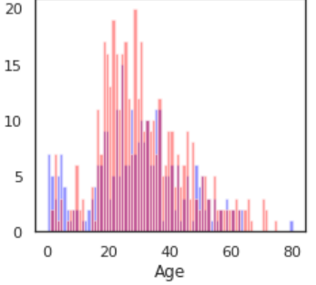
categorical features | barplots | sns.barplot('Sex', 'Survived', data=train) | 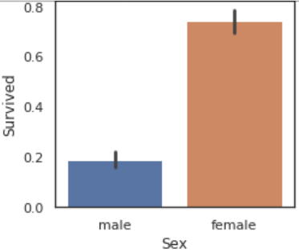

Another way of checking the actual numbers are through cross tables:
tab = pd.crosstab(train['SibSp'], train['Survived'])
Survived 0 1
SibSp
0 398 210
1 97 112
2 15 13
3 12 4
4 15 3
5 5 0
8 7 0

